Social Story for our First Session
My name is Heather and I am a therapist. A therapist is someone who helps people understand their feelings.

Soon you will be visiting my office with your mom and dad, just a mom or dad or someone else very special to you.

The outside of the office building looks like this.

When you enter the building you will long down a long hallway and find the last door on the right.

When you enter my office there is a waiting room that looks like this.
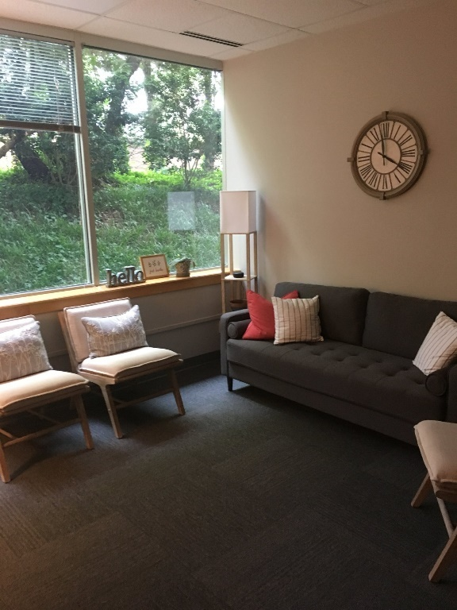

There are toys for you to play with and water to drink while you and your family member wait for me to greet you. There is also coffee and tea for your grownups.
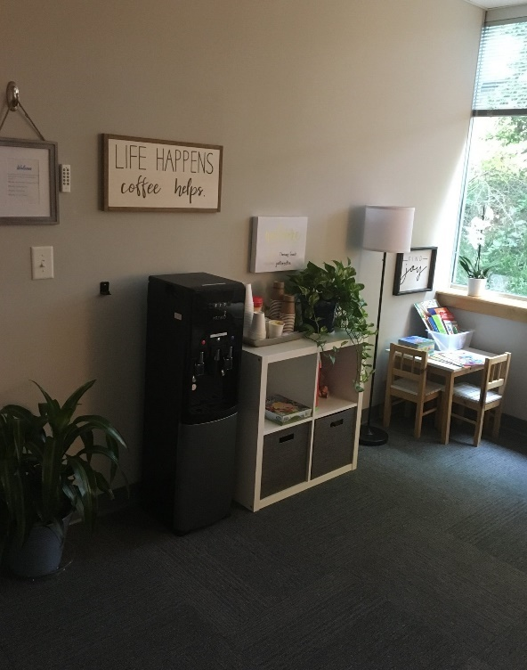

I will then invite you to visit my playroom. The playroom has a lot of toys to play with.
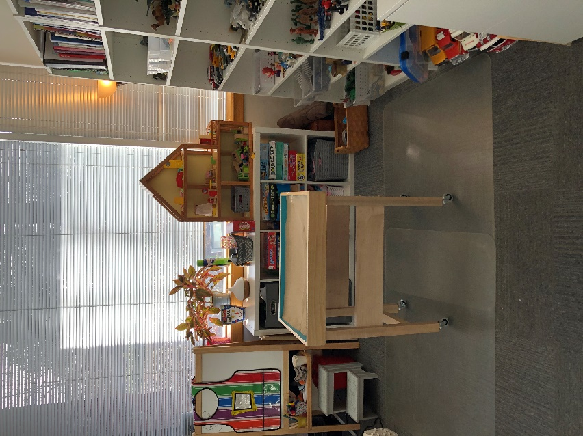

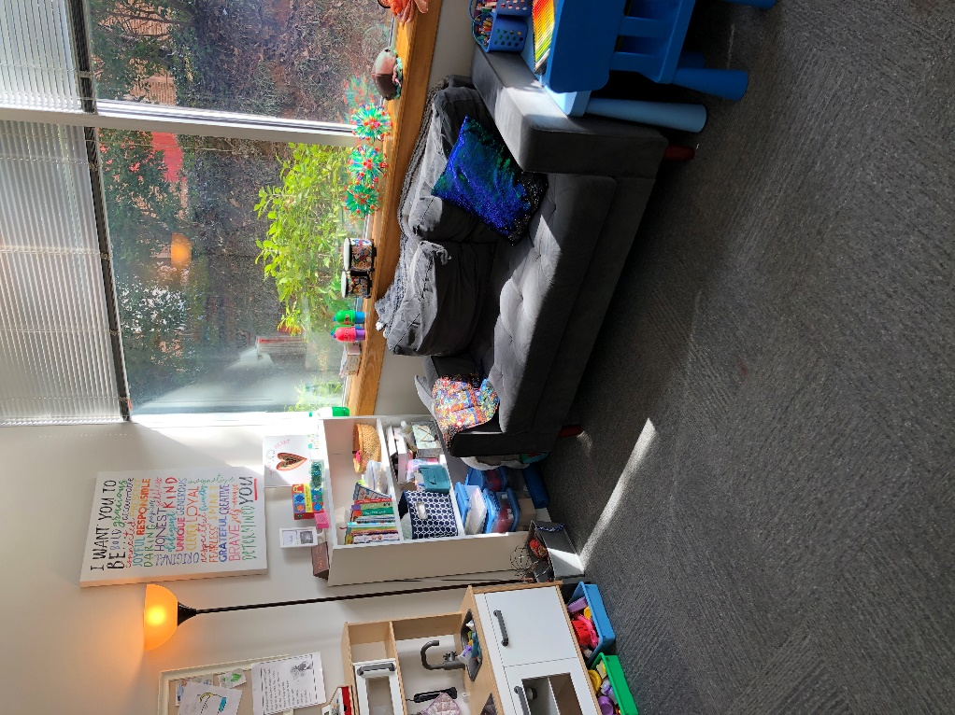

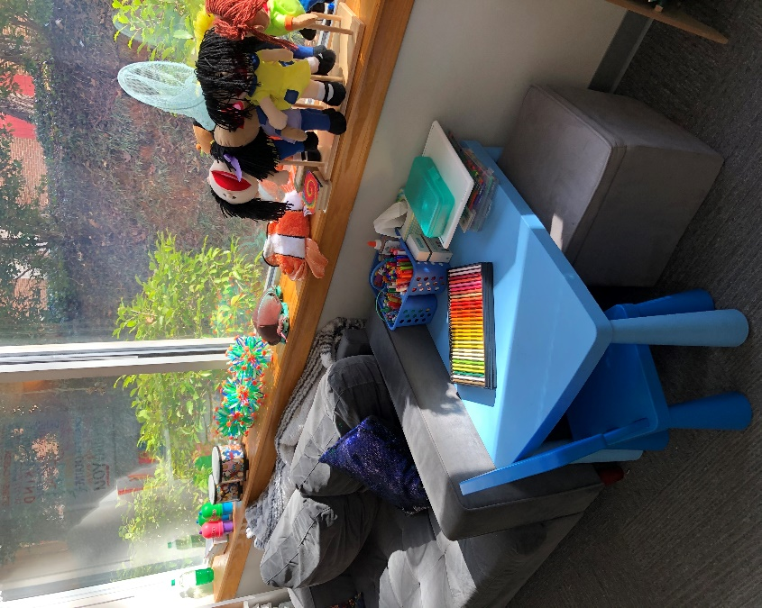

Sometimes parents and I meet in a different room to talk while you stay in the playroom and play. After I talk to your grownup then I’ll spend time talking with you.

Children, teenagers and even adults come to see me to talk about their feelings. We also talk about the good things in their life and things that are not going so well.
This Photo by Unknown Author is licensed under CC BY-NC

I am a safe person to share your feelings with. We do this by playing games, talking and playing with toys.

When is time to leave you can choose a gem to take with you. In a week or two I will see you again in my office with your parents.
This Photo by Unknown Author is licensed under CC BY-SA

I am excited to meet you.

